 **Centre of Excellence in Artificial Intelligence**

**AI42001:Machine Learning Foundations and Applications**

**Name**-Vaibhav Gupta **Roll Number**-20IE10041

**Date:**17-04-2024 **Assignment -**8

The below results are for random_seed=42 for the Random Forest regressor

Best hyperparameters for Random Forest Regressor: {'max_depth': 10, 'max_features': 3, 'n_estimators': 100}

Mean Squared Error (MSE) on validation set: 6.126949292417017

Mean Squared Error (MSE) on testing set: 16.344320060290453

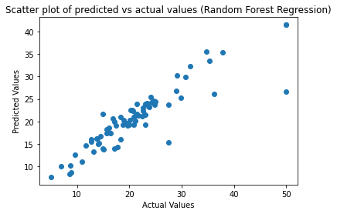

Comparing the results of AdaBoost using sklearn's implementation and the AdaBoost implemented from scratch:

1. **Best Hyperparameters**:
   * Sklearn's AdaBoost Classifier: {'n_estimators': 100}
   * AdaBoost implemented from scratch: Best number of weak learners: 50
2. **Accuracy on Validation Set**:
   * Sklearn's AdaBoost Classifier: Accuracy on validation set 0.9764705882352941
   * AdaBoost implemented from scratch: Best Accuracy on validation set: 0.9176470588235294
3. **Classification Report**:

* Sklearn's AdaBoost Classifier: Adaboost from scratch

precision recall f1-score support precision recall f1-score support

0 0.96 1.00 0.98 26 0 1.00 0.77 0.87 26

1 1.00 0.98 0.99 60 1 0.91 1.00 0.95 60

accuracy 0.99 86 accuracy 0.93 86

macro avg 0.98 0.99 0.99 86 macro avg 0.95 0.88 0.91 86

weighted avg 0.99 0.99 0.99 86 weighted avg 0.94 0.93 0.93 86

* **Confusion Matrix**:

Sklearn's AdaBoost Classifier: AdaBoost implemented from scratch:

[[26 0] [[20 6]

[ 1 59]] [ 0 60]]

Overall, we can observe that sklearn's AdaBoost Classifier achieved higher accuracy and precision compared to the AdaBoost implemented from scratch. This difference may be due to various factors such as the underlying implementation details, parameter tuning strategy, and randomness in the learning process. Additionally, the confusion matrices show differences in the distribution of true positive and false positive predictions between the two implementations.